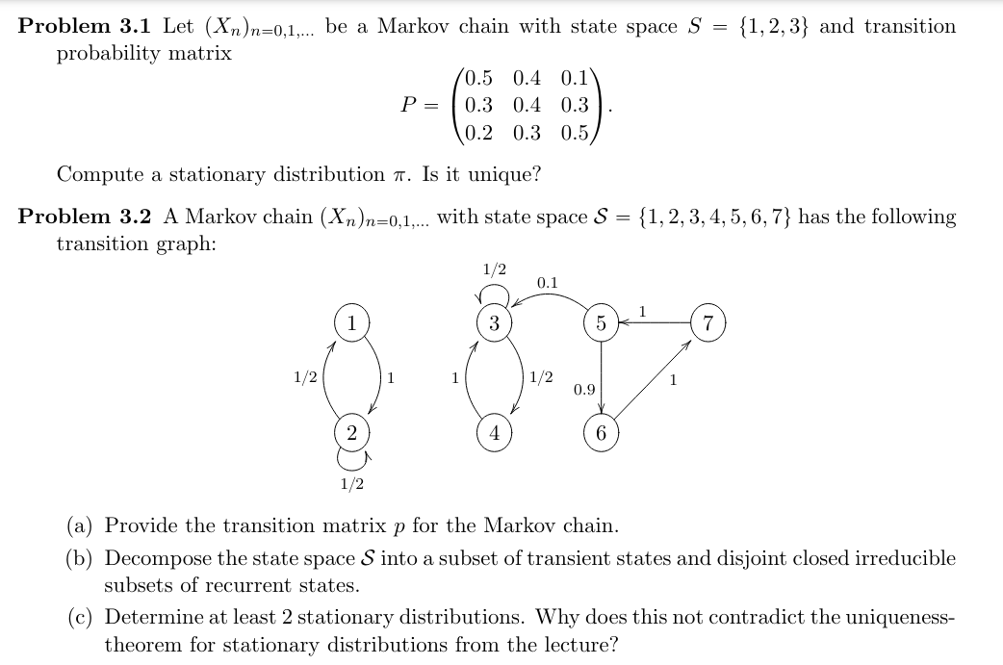

{"code":"\\begin{lalign*}\n&{\\pi p=\\pi\\;\\text{s.t.}\\;\\sum_{i\\in S}^{}\\pi\\left(i\\right)=1}\\\\\n&{\\begin{bmatrix}\n{\\pi\\left(1\\right)}&{\\pi\\left(2\\right)}&{\\pi\\left(3\\right)}\\\\\n\\end{bmatrix}\\begin{bmatrix}\n{.5}&{.4}&{.1}\\\\\n{.3}&{.4}&{.3}\\\\\n{.2}&{.3}&{.5}\\\\\n\\end{bmatrix}=\\begin{bmatrix}\n{\\pi\\left(1\\right)}&{\\pi\\left(2\\right)}&{\\pi\\left(3\\right)}\\\\\n\\end{bmatrix}}\\\\\n&{\\begin{bmatrix}\n{\\pi\\left(1\\right)}&{\\pi\\left(2\\right)}&{\\pi\\left(3\\right)}\\\\\n\\end{bmatrix}\\begin{bmatrix}\n{.5}&{.4}&{.1}\\\\\n{.3}&{.4}&{.3}\\\\\n{.2}&{.3}&{.5}\\\\\n\\end{bmatrix}-\\begin{bmatrix}\n{\\pi\\left(1\\right)}&{\\pi\\left(2\\right)}&{\\pi\\left(3\\right)}\\\\\n\\end{bmatrix}=\\begin{bmatrix}\n{0}&{0}&{0}\\\\\n\\end{bmatrix}}\\\\\n&{\\begin{bmatrix}\n{-.5\\cdot\\pi\\left(1\\right)+.3\\cdot\\pi\\left(2\\right)+.2\\cdot \\pi\\left(3\\right)}&{.4\\cdot\\pi\\left(1\\right)+-.6\\cdot\\pi\\left(2\\right)+.3\\cdot \\pi\\left(3\\right)}&{.1\\cdot\\pi\\left(1\\right)+.3\\cdot\\pi\\left(2\\right)+-.5\\cdot \\pi\\left(3\\right)}\\\\\n\\end{bmatrix}=\\begin{bmatrix}\n{0}&{0}&{0}\\\\\n\\end{bmatrix}}\\\\\n&{\\begin{bmatrix}\n{-.5}&{.3}&{.2}\\\\\n{.4}&{-.6}&{.3}\\\\\n{.1}&{.3}&{-.5}\\\\\n{1}&{1}&{1}\\\\\n\\end{bmatrix}\\begin{bmatrix}\n{\\pi\\left(1\\right)}\\\\\n{\\pi\\left(2\\right)}\\\\\n{\\pi\\left(3\\right)}\\\\\n\\end{bmatrix}\\equiv\\begin{bmatrix}\n{-.5}&{.3}&{.2}\\\\\n{}&{-.36}&{.46}\\\\\n{}&{}&{31/9}\\\\\n{}&{}&{}\\\\\n\\end{bmatrix}\\begin{bmatrix}\n{\\pi\\left(1\\right)}\\\\\n{\\pi\\left(2\\right)}\\\\\n{\\pi\\left(3\\right)}\\\\\n\\end{bmatrix}=\\begin{bmatrix}\n{0}\\\\\n{0}\\\\\n{1}\\\\\n{0}\\\\\n\\end{bmatrix}\\implies\\begin{bmatrix}\n{\\pi\\left(1\\right)}\\\\\n{\\pi\\left(2\\right)}\\\\\n{\\pi\\left(3\\right)}\\\\\n\\end{bmatrix}=\\begin{bmatrix}\n{.339}\\\\\n{.371}\\\\\n{.290}\\\\\n\\end{bmatrix}}\\\\\n&{}\\\\\n&{}\\\\\n&{\\text{since}\\;\\text{irreducible}\\;\\implies \\text{exists}\\;\\text{at}\\;\\text{most}\\;\\text{a}\\;\\text{stationary}\\;\\text{distrib}\\;\\text{in}\\;\\text{this}\\;\\text{M.C.}\\implies\\text{this}\\;\\text{is}\\;\\text{a}\\;\\text{unique}\\;\\text{stationary}\\;\\text{distrib}}\t\n\\end{lalign*}","type":"lalign*","aid":null,"font":{"color":"#000000","family":"Arial","size":8.5},"id":"1","backgroundColor":"#ffffff","ts":1718141746710,"cs":"mGEcIeBRFwavDLDax+Gibw==","size":{"width":652,"height":280}}



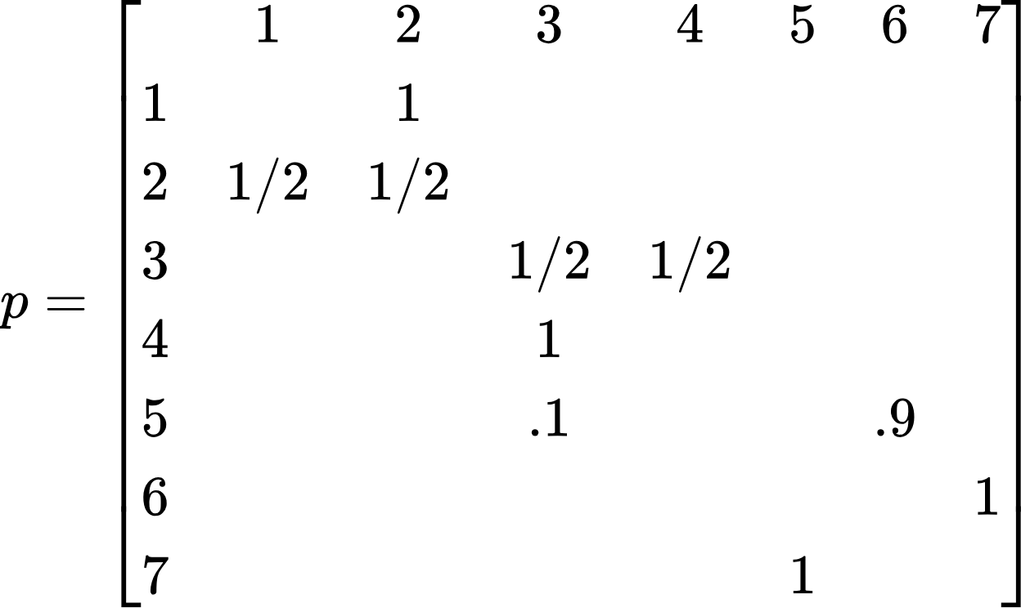



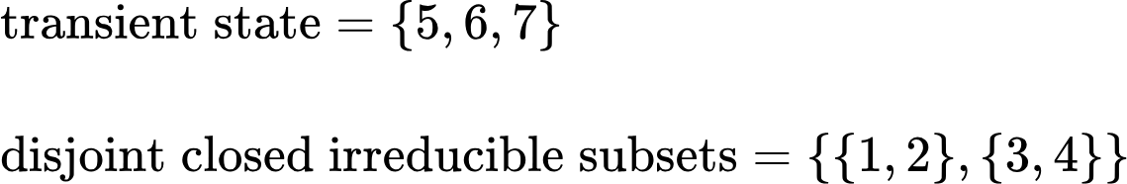



{"font":{"family":"Arial","size":11,"color":"#000000"},"code":"\\begin{lalign*}\n&{p_{1,}p_{2}\\subseteq p}\\\\\n&{}\\\\\n&{p_{1}=\\begin{bmatrix}\n{}&{1}&{2}\\\\\n{1}&{}&{1}\\\\\n{2}&{1/2}&{1/2}\\\\\n\\end{bmatrix}}\\\\\n&{\\begin{bmatrix}\n{\\pi\\left(1\\right)}&{\\pi\\left(2\\right)}\\\\\n\\end{bmatrix}\\begin{bmatrix}\n{}&{1}&{2}\\\\\n{1}&{}&{1}\\\\\n{2}&{1/2}&{1/2}\\\\\n\\end{bmatrix}-\\begin{bmatrix}\n{\\pi\\left(1\\right)}&{\\pi\\left(2\\right)}\\\\\n\\end{bmatrix}=\\begin{bmatrix}\n{\\pi\\left(1\\right)}&{\\pi\\left(2\\right)}\\\\\n\\end{bmatrix}\\left(\\begin{bmatrix}\n{}&{1}&{2}\\\\\n{1}&{}&{1}\\\\\n{2}&{1/2}&{1/2}\\\\\n\\end{bmatrix}-\\begin{bmatrix}\n{}&{1}&{2}\\\\\n{1}&{1}&{}\\\\\n{2}&{}&{1}\\\\\n\\end{bmatrix}\\right)}\\\\\n&{\\begin{bmatrix}\n{\\pi\\left(1\\right)}&{\\pi\\left(2\\right)}\\\\\n\\end{bmatrix}\\left(\\begin{bmatrix}\n{}&{1}&{2}\\\\\n{1}&{-1}&{1}\\\\\n{2}&{1/2}&{-1/2}\\\\\n\\end{bmatrix}\\right)=\\begin{bmatrix}\n{0}&{0}\\\\\n\\end{bmatrix}}\\\\\n&{\\begin{bmatrix}\n{-\\pi\\left(1\\right)+.5\\cdot\\pi\\left(2\\right)}&{\\pi\\left(1\\right)-.5\\cdot\\pi\\left(2\\right)}\\\\\n\\end{bmatrix}=\\begin{bmatrix}\n{0}&{0}\\\\\n\\end{bmatrix}}\\\\\n&{}\\\\\n&{\\begin{bmatrix}\n{-1}&{.5}\\\\\n{1}&{-.5}\\\\\n{1}&{1}\\\\\n\\end{bmatrix}\\begin{bmatrix}\n{\\pi\\left(1\\right)}\\\\\n{\\pi\\left(2\\right)}\\\\\n\\end{bmatrix}=\\begin{bmatrix}\n{0}\\\\\n{0}\\\\\n{1}\\\\\n\\end{bmatrix}}\\\\\n&{\\begin{bmatrix}\n{-1}&{.5}\\\\\n{1}&{1}\\\\\n\\end{bmatrix}\\begin{bmatrix}\n{\\pi\\left(1\\right)}\\\\\n{\\pi\\left(2\\right)}\\\\\n\\end{bmatrix}=\\begin{bmatrix}\n{0}\\\\\n{1}\\\\\n\\end{bmatrix}\\implies\\begin{bmatrix}\n{\\pi\\left(1\\right)}\\\\\n{\\pi\\left(2\\right)}\\\\\n\\end{bmatrix}=\\begin{bmatrix}\n{1/3}\\\\\n{2/3}\\\\\n\\end{bmatrix}}\\\\\n&{}\\\\\n&{\\pi p_{2}-\\pi=\\begin{bmatrix}\n{\\pi\\left(1\\right)}&{\\pi\\left(2\\right)}\\\\\n\\end{bmatrix}\\begin{bmatrix}\n{}&{3}&{4}\\\\\n{3}&{1/2}&{1/2}\\\\\n{4}&{1}&{}\\\\\n\\end{bmatrix}-\\begin{bmatrix}\n{\\pi\\left(1\\right)}&{\\pi\\left(2\\right)}\\\\\n\\end{bmatrix}=\\begin{bmatrix}\n{\\pi\\left(1\\right)}&{\\pi\\left(2\\right)}\\\\\n\\end{bmatrix}\\left(\\begin{bmatrix}\n{}&{3}&{4}\\\\\n{3}&{-1/2}&{1/2}\\\\\n{4}&{1}&{-1}\\\\\n\\end{bmatrix}\\right)}\\\\\n&{\\begin{bmatrix}\n{-.5\\cdot\\pi\\left(1\\right)+\\pi\\left(2\\right)}&{.5\\cdot\\pi\\left(1\\right)-\\pi\\left(2\\right)}\\\\\n\\end{bmatrix}=\\begin{bmatrix}\n{0}&{0}\\\\\n\\end{bmatrix}}\\\\\n&{\\begin{bmatrix}\n{-.5}&{1}\\\\\n{.5}&{-1}\\\\\n{1}&{1}\\\\\n\\end{bmatrix}\\begin{bmatrix}\n{\\pi\\left(1\\right)}\\\\\n{\\pi\\left(2\\right)}\\\\\n\\end{bmatrix}\\equiv\\begin{bmatrix}\n{0}\\\\\n{0}\\\\\n{1}\\\\\n\\end{bmatrix}}\\\\\n&{\\begin{bmatrix}\n{-.5}&{1}\\\\\n{1}&{1}\\\\\n\\end{bmatrix}\\begin{bmatrix}\n{\\pi\\left(1\\right)}\\\\\n{\\pi\\left(2\\right)}\\\\\n\\end{bmatrix}=\\begin{bmatrix}\n{0}\\\\\n{1}\\\\\n\\end{bmatrix}\\implies\\begin{bmatrix}\n{\\pi\\left(1\\right)}\\\\\n{\\pi\\left(2\\right)}\\\\\n\\end{bmatrix}=\\begin{bmatrix}\n{2/3}\\\\\n{1/3}\\\\\n\\end{bmatrix}}\\\\\n&{\\therefore\\begin{bmatrix}\n{1/3}&{2/3}&{0}&{0}&{0}&{0}&{0}\\\\\n\\end{bmatrix},\\begin{bmatrix}\n{0}&{0}&{2/3}&{1/3}&{0}&{0}&{0}\\\\\n\\end{bmatrix}\\;\\text{are}\\;\\text{both}\\;\\text{stationary}\\;\\text{distr}}\\\\\n&{}\\\\\n&{\\text{doe}\\text{s}\\;\\text{not}\\;\\text{contradict}\\;\\text{thm}\\;\\text{because}\\;\\text{this}\\;\\text{M.C.}\\;\\text{is}\\;\\text{not}\\;\\text{irreducible}\\;1\\to!3,3\\to!1}\t\n\\end{lalign*}","id":"4","type":"lalign*","aid":null,"backgroundColor":"#ffffff","ts":1713853416994,"cs":"KyUDritUI4RDSBFN7hoLEw==","size":{"width":680,"height":709}}

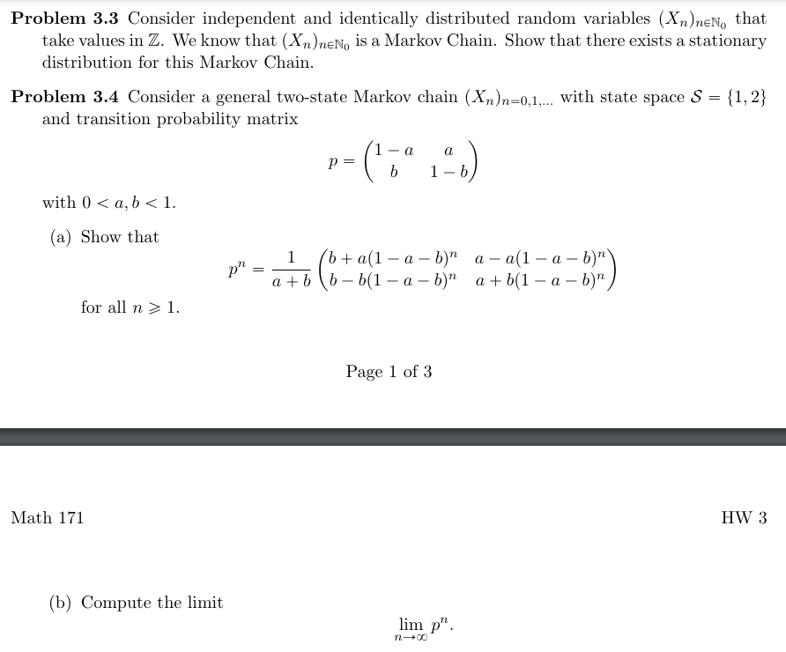

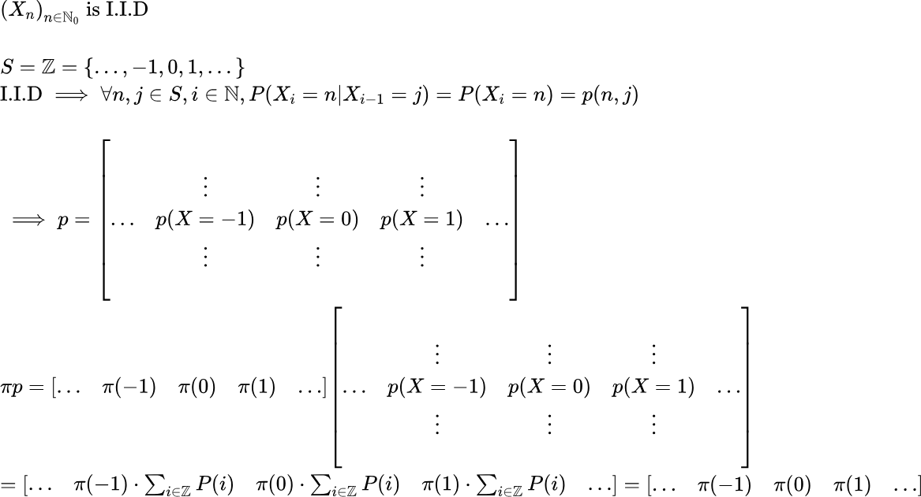



{"backgroundColorModified":false,"backgroundColor":"#ffffff","code":"\\begin{lalign*}\n&{p^{n}=\\begin{bmatrix}\n{1-a}&{a}\\\\\n{b}&{1-b}\\\\\n\\end{bmatrix}^{n}}\\\\\n&{}\\\\\n&{\\text{when}\\;n=1,}\\\\\n&{p^{1}=\\begin{bmatrix}\n{1-a}&{a}\\\\\n{b}&{1-b}\\\\\n\\end{bmatrix}}\\\\\n&{\\frac{1}{a+b}\\begin{bmatrix}\n{b+a\\left(1-a-b\\right)^{n}}&{a-a\\left(1-a-b\\right)^{n}}\\\\\n{b-b\\left(1-a-b\\right)^{n}}&{a+b\\left(1-a-b\\right)^{n}}\\\\\n\\end{bmatrix}=\\frac{1}{a+b}\\begin{bmatrix}\n{b+a\\left(1-a-b\\right)}&{a-a\\left(1-a-b\\right)}\\\\\n{b-b\\left(1-a-b\\right)}&{a+b\\left(1-a-b\\right)}\\\\\n\\end{bmatrix}}\\\\\n&{=\\begin{bmatrix}\n{\\frac{b+a-a^{2}-ab}{a+b}}&{\\frac{a-a+a^{2}+ab}{a+b}}\\\\\n{\\frac{b-b+ab+b^{2}}{a+b}}&{\\frac{a+b-ab-b^{2}}{a+b}}\\\\\n\\end{bmatrix}=\\begin{bmatrix}\n{\\frac{a\\left(1-a\\right)+b\\left(1-a\\right)}{a+b}}&{\\frac{a\\left(a+b\\right)}{a+b}}\\\\\n{\\frac{b\\left(a+b\\right)}{a+b}}&{\\frac{a\\left(1-b\\right)+b\\left(1-b\\right)}{a+b}}\\\\\n\\end{bmatrix}=\\begin{bmatrix}\n{1-a}&{a}\\\\\n{b}&{1-b}\\\\\n\\end{bmatrix}}\\\\\n&{}\\\\\n&{\\text{IH:}\\;p^{n}=\\frac{1}{a+b}\\begin{bmatrix}\n{b+a\\left(1-a-b\\right)^{n}}&{a-a\\left(1-a-b\\right)^{n}}\\\\\n{b-b\\left(1-a-b\\right)^{n}}&{a+b\\left(1-a-b\\right)^{n}}\\\\\n\\end{bmatrix}}\\\\\n&{\\text{WTS:}\\;p^{n+1}=\\frac{1}{a+b}\\begin{bmatrix}\n{b+a\\left(1-a-b\\right)^{n+1}}&{a-a\\left(1-a-b\\right)^{n+1}}\\\\\n{b-b\\left(1-a-b\\right)^{n+1}}&{a+b\\left(1-a-b\\right)^{n+1}}\\\\\n\\end{bmatrix}}\\\\\n&{}\\\\\n&{p^{n+1}=p^{n}\\cdot p=\\frac{1}{a+b}\\begin{bmatrix}\n{b+a\\left(1-a-b\\right)^{n}}&{a-a\\left(1-a-b\\right)^{n}}\\\\\n{b-b\\left(1-a-b\\right)^{n}}&{a+b\\left(1-a-b\\right)^{n}}\\\\\n\\end{bmatrix}\\cdot\\begin{bmatrix}\n{1-a}&{a}\\\\\n{b}&{1-b}\\\\\n\\end{bmatrix}}\\\\\n&{p^{n+1}=\\frac{1}{a+b}\\begin{bmatrix}\n{\\left(b+a\\left(1-a-b\\right)^{n}\\right)\\left(1-a\\right)+\\left(a-a\\left(1-a-b\\right)^{n}\\right)\\left(b\\right)}&{\\left(b+a\\left(1-a-b\\right)^{n}\\right)\\left(a\\right)+\\left(a-a\\left(1-a-b\\right)^{n}\\right)\\left(1-b\\right)}\\\\\n{\\left(b-b\\left(1-a-b\\right)^{n}\\right)\\left(1-a\\right)+\\left(a+b\\left(1-a-b\\right)^{n}\\right)\\left(b\\right)}&{\\left(b-b\\left(1-a-b\\right)^{n}\\right)\\left(a\\right)+\\left(a+b\\left(1-a-b\\right)^{n}\\right)\\left(1-b\\right)}\\\\\n\\end{bmatrix}}\\\\\n&{p^{n+1}=\\frac{1}{a+b}\\begin{bmatrix}\n{b+a\\left(1-a-b\\right)^{n+1}}&{a-a\\left(1-a-b\\right)^{n+1}}\\\\\n{b-b\\left(1-a-b\\right)^{n+1}}&{a+b\\left(1-a-b\\right)^{n+1}}\\\\\n\\end{bmatrix}}\t\n\\end{lalign*}","type":"lalign*","id":"6","aid":null,"font":{"size":8.5,"family":"Arial","color":"#000000"},"ts":1713856792084,"cs":"rQK9wYieKqnnEj6QCifHkQ==","size":{"width":680,"height":420}}



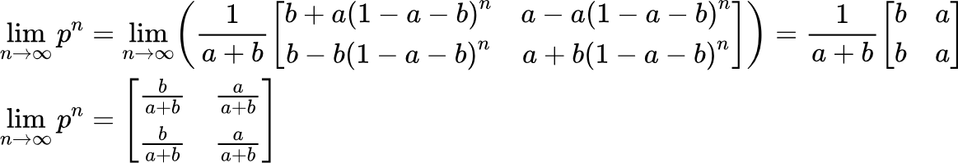

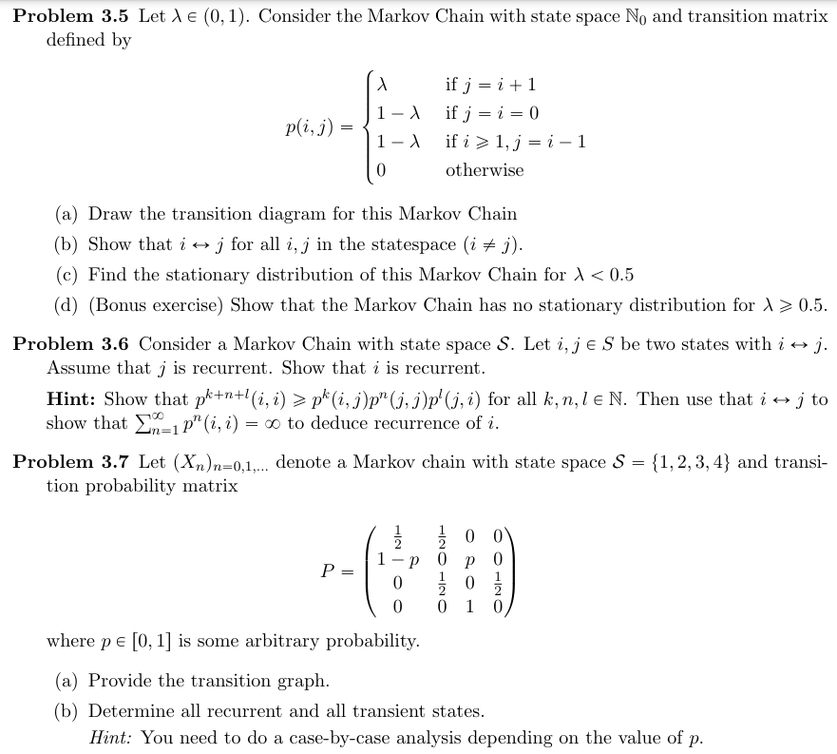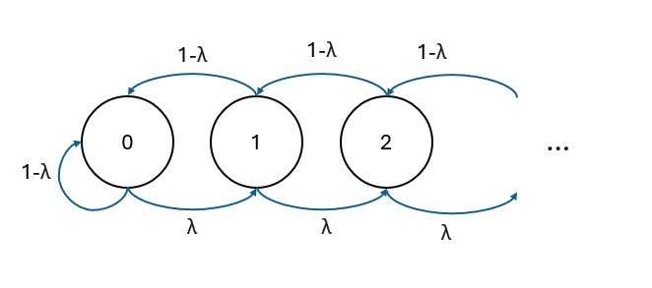



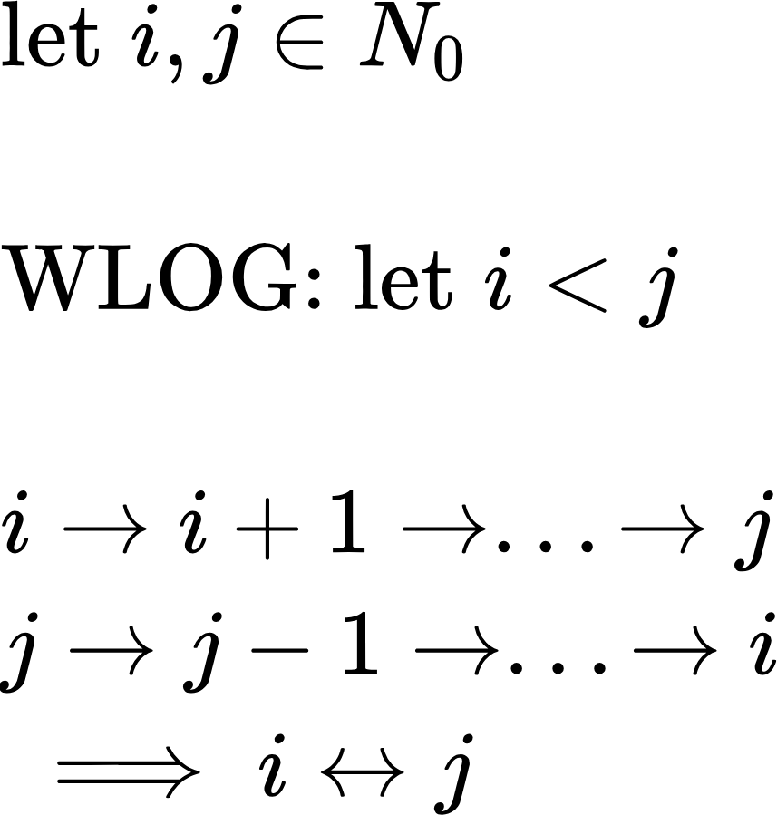



{"code":"\\begin{lalign*}\n&{\\begin{bmatrix}\n{\\pi\\left(0\\right)}&{\\pi\\left(1\\right)}&{\\pi\\left(2\\right)}&{\\dots}\\\\\n\\end{bmatrix}\\begin{bmatrix}\n{1-\\lambda}&{\\lambda}&{0}&{\\dots}\\\\\n{1-\\lambda}&{0}&{\\lambda}&{\\dots}\\\\\n{0}&{1-\\lambda}&{0}&{\\ddots}\\\\\n{\\vdots}&{\\vdots}&{\\ddots}&{\\ddots}\\\\\n\\end{bmatrix}-\\begin{bmatrix}\n{\\pi\\left(0\\right)}&{\\pi\\left(1\\right)}&{\\pi\\left(2\\right)}&{\\dots}\\\\\n\\end{bmatrix}=\\begin{bmatrix}\n{0}&{0}&{0}&{\\dots}\\\\\n\\end{bmatrix}}\\\\\n&{\\begin{bmatrix}\n{\\pi\\left(0\\right)}&{\\pi\\left(1\\right)}&{\\pi\\left(2\\right)}&{\\dots}\\\\\n\\end{bmatrix}\\begin{bmatrix}\n{-\\lambda}&{\\lambda}&{0}&{\\dots}\\\\\n{1-\\lambda}&{-1}&{\\lambda}&{\\dots}\\\\\n{0}&{1-\\lambda}&{-1}&{\\ddots}\\\\\n{\\vdots}&{\\vdots}&{\\ddots}&{\\ddots}\\\\\n\\end{bmatrix}=\\begin{bmatrix}\n{0}&{0}&{0}&{\\dots}\\\\\n\\end{bmatrix}}\\\\\n&{}\\\\\n&{=\\begin{bmatrix}\n{\\left(-\\lambda\\right)\\cdot\\pi\\left(0\\right)+\\left(1-\\lambda\\right)\\cdot\\pi\\left(1\\right)}&{\\left(\\lambda\\right)\\cdot\\pi\\left(0\\right)+\\left(-1\\right)\\pi\\left(1\\right)+\\left(1-\\lambda\\right)\\cdot\\pi\\left(2\\right)}&{\\left(\\lambda\\right)\\cdot\\pi\\left(1\\right)+\\left(-1\\right)\\cdot \\pi\\left(2\\right)+\\left(-\\lambda\\right)\\cdot\\pi\\left(3\\right)}&{\\dots}\\\\\n\\end{bmatrix}=\\begin{bmatrix}\n{0}&{0}&{0}&{\\dots}\\\\\n\\end{bmatrix}}\\\\\n&{}\\\\\n&{\\begin{bmatrix}\n{\\sum_{i=1}^{\\left|\\mathbb{N}_{0}\\right|}\\pi\\left(i\\right)}\\\\\n{\\left(-\\lambda\\right)\\pi\\left(0\\right)+\\left(1-\\lambda\\right)\\pi\\left(1\\right)}\\\\\n{\\left(\\lambda\\right)\\pi\\left(0\\right)+\\left(-1\\right)\\pi\\left(1\\right)+\\left(1-\\lambda\\right)\\pi\\left(2\\right)}\\\\\n{\\left(\\lambda\\right)\\pi\\left(1\\right)+\\left(-1\\right)\\pi\\left(2\\right)+\\left(1-\\lambda\\right)\\pi\\left(3\\right)}\\\\\n{\\left(\\lambda\\right)\\pi\\left(2\\right)+\\left(-1\\right)\\pi\\left(3\\right)+\\left(1-\\lambda\\right)\\pi\\left(4\\right)}\\\\\n{\\vdots}\\\\\n\\end{bmatrix}=\\begin{bmatrix}\n{1}\\\\\n{0}\\\\\n{0}\\\\\n{0}\\\\\n{0}\\\\\n{\\vdots}\\\\\n\\end{bmatrix}}\\\\\n&{\\left(-\\lambda\\right)\\pi\\left(0\\right)+\\left(1-\\lambda\\right)\\pi\\left(1\\right)=0\\implies \\pi\\left(0\\right)=\\left(\\frac{1-\\lambda}{\\lambda}\\right)\\pi\\left(1\\right)}\\\\\n&{\\left(\\lambda\\right)\\pi\\left(0\\right)+\\left(-1\\right)\\pi\\left(1\\right)+\\left(1-\\lambda\\right)\\pi\\left(2\\right)=\\left(\\lambda\\right)\\left(\\frac{1-\\lambda}{\\lambda}\\right)\\pi\\left(1\\right)+\\left(-1\\right)\\pi\\left(1\\right)+\\left(1-\\lambda\\right)\\pi\\left(2\\right)=0\\implies \\pi\\left(1\\right)=\\left(\\frac{1-\\lambda}{\\lambda}\\right)\\pi\\left(2\\right)}\\\\\n&{\\implies \\forall i\\in\\mathbb{N}_{0},\\pi\\left(0\\right)=\\left(\\frac{1-\\lambda}{\\lambda}\\right)\\pi\\left(1\\right)=\\left(\\frac{1-\\lambda}{\\lambda}\\right)^{2}\\pi\\left(2\\right)=...\\implies \\pi\\left(n\\right)=\\left(\\frac{1-\\lambda}{\\lambda}\\right)^{-n}\\pi\\left(0\\right)\\implies\\pi\\left(n\\right)=\\left(\\frac{\\lambda}{1-\\lambda}\\right)^{n}\\pi\\left(0\\right)}\\\\\n&{}\\\\\n&{\\sum_{i=0}^{\\left|\\mathbb{N}_{0}\\right|}\\pi\\left(i\\right)=\\sum_{i=0}^{\\left|\\mathbb{N}_{0}\\right|}\\left(\\frac{\\lambda}{1-\\lambda}\\right)^{n}\\pi\\left(0\\right)=\\pi\\left(0\\right)\\cdot\\sum_{i=0}^{\\left|\\mathbb{N}_{0}\\right|}\\left(\\frac{\\lambda}{1-\\lambda}\\right)^{n}=1}\\\\\n&{\\text{assuming:}\\;\\frac{\\lambda}{1-\\lambda}<1}\\\\\n&{\\pi\\left(0\\right)\\cdot\\sum_{i=0}^{\\left|\\mathbb{N}_{0}\\right|}\\left(\\frac{\\lambda}{1-\\lambda}\\right)^{n}=\\pi\\left(0\\right)\\cdot\\frac{1}{1-\\frac{\\lambda}{1-\\lambda}}=\\pi\\left(0\\right)\\cdot\\left(\\frac{1-\\lambda}{1-2\\lambda}\\right)=1}\\\\\n&{\\pi\\left(0\\right)=\\left(\\frac{1-2\\lambda}{1-\\lambda}\\right)}\\\\\n&{\\implies\\text{stationary}\\;\\text{distrib:}\\;\\begin{bmatrix}\n{\\left(\\frac{1-2\\lambda}{1-\\lambda}\\right)}&{\\left(\\frac{\\lambda}{1-\\lambda}\\right)\\left(\\frac{1-2\\lambda}{1-\\lambda}\\right)}&{\\left(\\frac{\\lambda}{1-\\lambda}\\right)^{2}\\left(\\frac{1-2\\lambda}{1-\\lambda}\\right)}&{\\dots}\\\\\n\\end{bmatrix}}\\\\\n&{}\t\n\\end{lalign*}","backgroundColor":"#ffffff","type":"lalign*","id":"9","font":{"size":7.5,"family":"Arial","color":"#000000"},"aid":null,"ts":1714111511364,"cs":"rmDembZ58AjjbIhEQWKCWg==","size":{"width":661,"height":593}}



